Greiner Visor – the professional COVID-19 protective mask

Greiner Assistec is an expert in plastics processing. In response to the current situation, the company has now started developing and producing protective masks made of plastic. The team is using its existing expertise to spontaneously implement new products that are urgently needed at this time. In this way, Greiner Assistec is supporting people and other companies during the present COVID-19 crisis.

Kremsmünster, Austria, April 2020. Greiner Assistec is now supplying a high-quality face covering for various lines of work – the Greiner Visor. The innovative plastic shield offers maximum protection and reduces the risk of infection with COVID-19 in today’s much-altered world of work. The visor is equally suitable for a company’s own employees, as a giveaway with a practical benefit in the current situation, or as a sought-after donation in kind.

Mastering extremes together
Greiner Assistec is driven by complexity – even in normal circumstances. This drive is also reflected in the company’s slogan, “Mastering complexity,” which extends beyond producing custom plastic parts and products to encompass the long-term partnerships it shares with its customers. Greiner Assistec is therefore focusing on overcoming the extreme situation we are currently facing due to COVID-19 together with its customers and the whole of society. This means taking a rapid, flexible approach to make precisely those products that are needed right now. One example is a plastic shield that provides reliable protection against fluids and droplets, and therefore against COVID-19 as well. The Greiner Visor has already proven itself in use, offering clear visibility and protection against the virus in one. Thanks to short delivery times, the fact that it is comfortable to wear, and flexible size adjustment, the visor is exactly the right product at the right time.

Plastic solution for reliable everyday protection
The new Greiner Visor can be used in various fields of occupation. Because it provides Class 1 eye protection in accordance with DIN EN 166 standards, the visor is ideal for medical personnel, ensuring that doctors and nursing staff have the right protection, even when working in direct contact with patients infected with COVID-19. It also offers protection for emergency workers in the police, fire service, and civil protection forces as well as for people in other official roles who come into contact with potentially infected citizens. A further area of application is the food supply chain, where the visor protects foodstuffs, employees, and customers alike in dairies, food production facilities, and serving counters in butchers and bakeries.

“In producing the Greiner Visor, the team at Greiner Assistec is taking advantage of our core area of expertise – processing plastics – to deliver a product we have pioneered ourselves. In this situation, we see this as both a challenge and our duty. We believe we can overcome the COVID-19 crisis by sticking together, which is why we’re taking on a share of the responsibility for ensuring the safety of people in Europe. We applaud everyone who has a really tough job to do out there right now – whether in the health-care sector, in the police, or as part of the food supply chain,” says Karl Berger, Vice President Greiner Assistec. “As experts in the field of plastics processing, we have the skills and knowledge needed to implement these kinds of product innovations at relatively short notice – which means that we’re able to help in situations like the one we’re currently facing.”

A flexible response and short delivery times
The Greiner Visor was rapidly developed in response to the current situation, and production started immediately. It is available now for delivery at short notice. The protective shields are packaged in boxes of 40 and delivered in pallets containing 480 units. They are equally suitable for use within companies, as practical giveaways for customers and partners, or as a donation in kind to communities, organizations, and other institutions.

Highly flexible with outstanding product characteristics
The Greiner Visor may be new, but it is already proven itself as a popular protective shield in practical use. It is easy to assemble, extremely comfortable thanks to its low weight, and has good cleaning characteristics, making it suitable for day-to-day use in every sense. The shield is made of high-quality, durable plastic and adjusts flexibly to any head size. It provides reliable protection against all types of fluids, including droplets, and against dust.

For more information on the product, please visit: greiner-assistec.com/en/greiner-visor.

About Greiner Packaging & Greiner Assistec
Greiner Packaging is a leading European manufacturer of plastic packaging in the food and nonfood sectors. The company has enjoyed a reputation for outstanding solutions expertise in the fields of development, design, production, and decoration for 60 years. Greiner Packaging responds to the challenges of the market with two business units: Packaging and Assistec. While the Packaging unit focuses on innovative packaging solutions in the food and nonfood segments, the Assistec unit is dedicated to producing custom-made technical parts and transit packaging solutions. Greiner Packaging employs a workforce of around 4,800 at more than 30 locations in 19 countries around the world. In 2018, the company generated annual sales revenues of EUR 673 million (including joint ventures), which represents more than one third of Greiner’s total revenue.

Text and image:

Text document and high-resolution images for download:
https://mam.greiner.at/pinaccess/showpin.do?pinCode=x7kD1HMmjoef

Images for royalty-free use, credit: Greiner Packaging

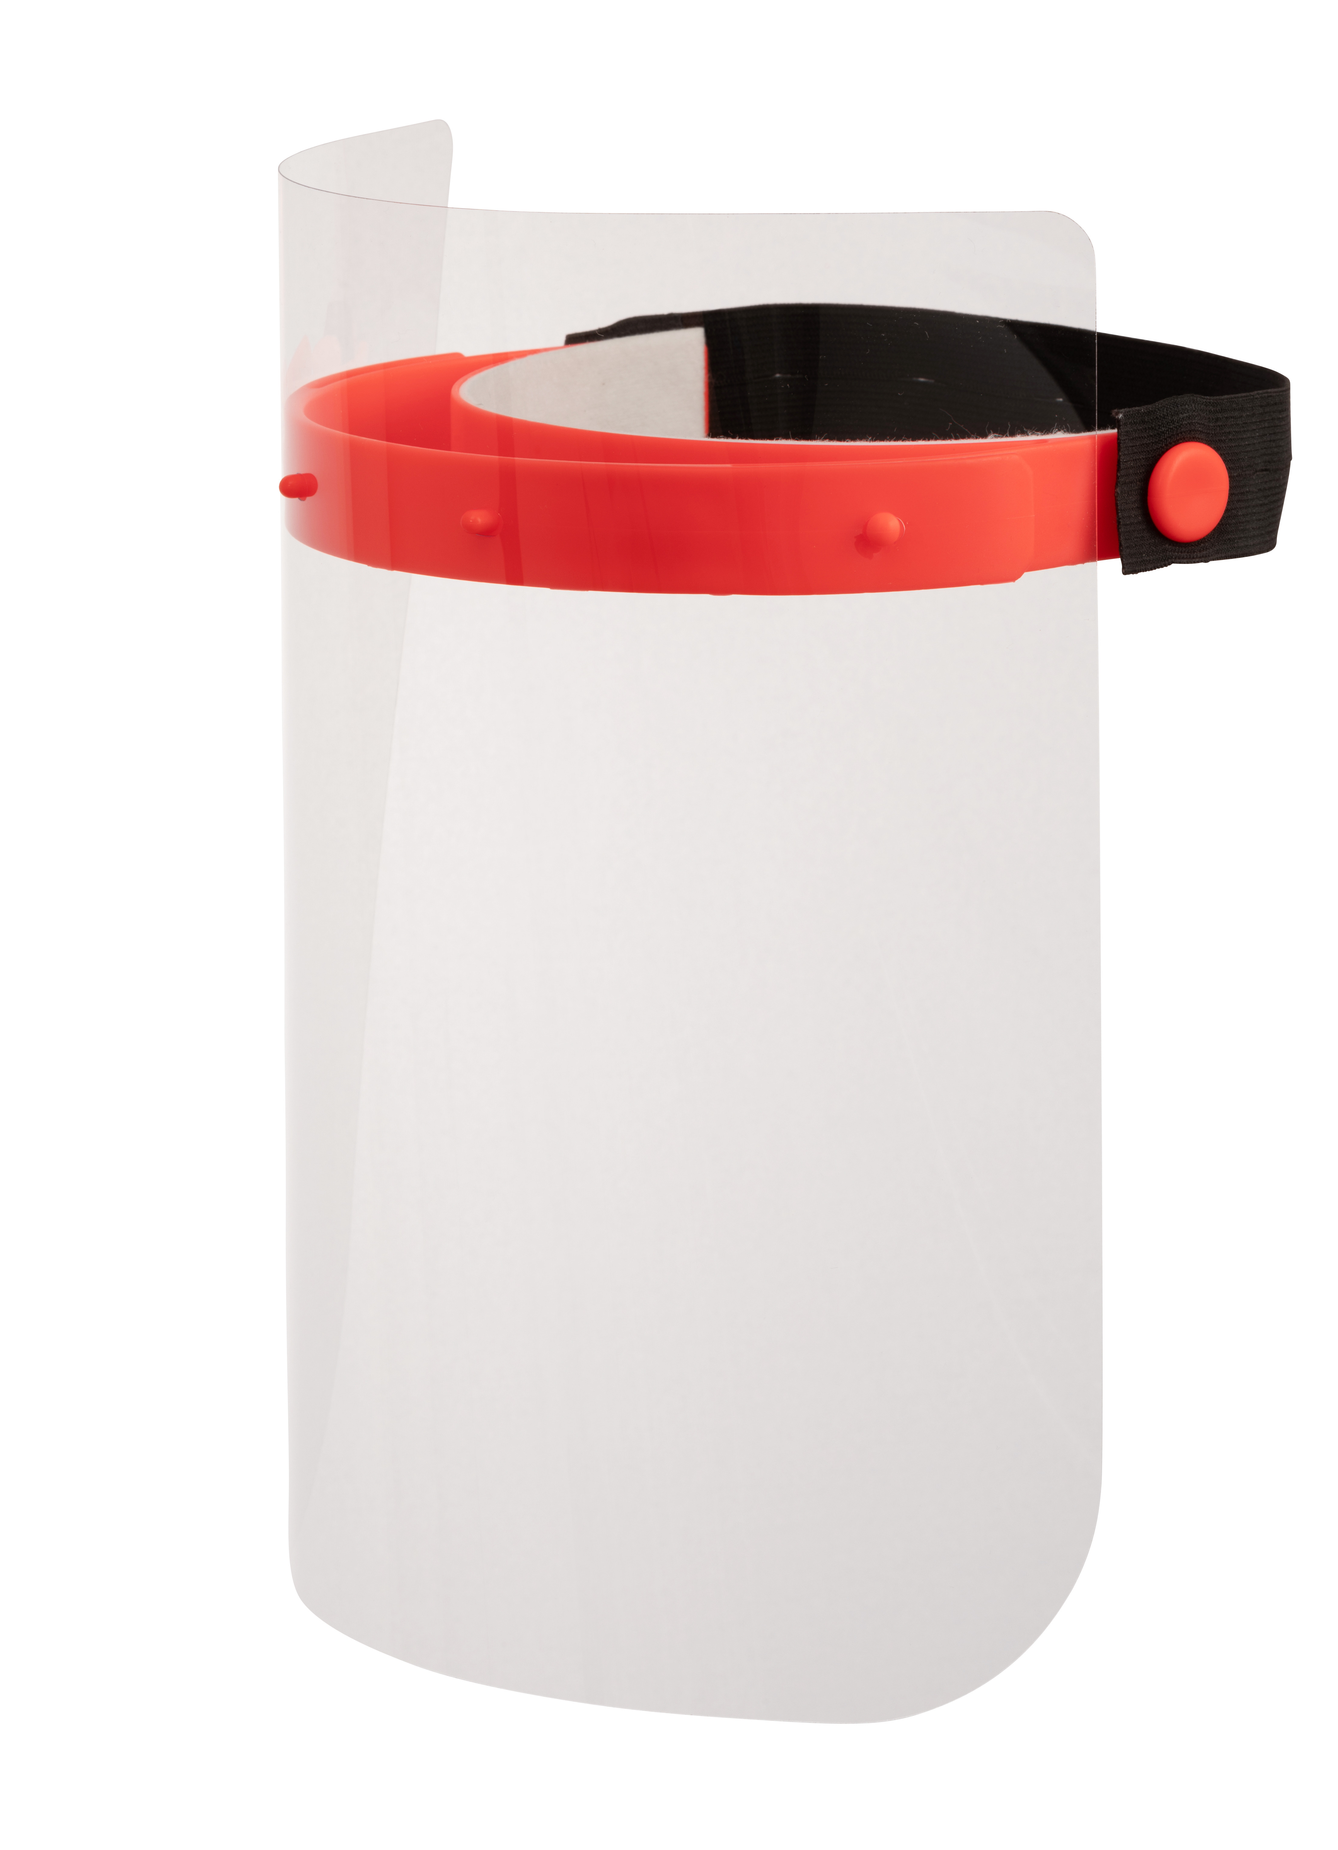

Caption: Reliable protection against fluids and droplets in day-to-day work: the new Greiner Visor from Greiner Assistec.

Please direct any questions to:
Roland Kaiblinger I Account Executive
SPS MARKETING GmbH | B 2 Businessclass | Linz, Stuttgart
Jaxstrasse 2–4, 4020 Linz, Austria
Tel. +43 (0) 732 60 50 38-19
E-mail: r.kaiblinger@sps-marketing.com
www.sps-marketing.com

