Celestica recognizes Greiner Assistec as an honouree in its 2016 Total Cost of Ownership Supplier Awards Program

Kremsmünster, October 2017. Greiner Assistec announced today it has been recognized as an honouree in the 2016 Total Cost of Ownership (TCOOTM) Supplier Award program from Celestica, a leader in design, manufacturing and supply chain solutions for the world's most innovative companies. Celestica’s awards program recognizes suppliers that provide the best TCOOTM performance to Celestica and support the company’s overall business objectives.

“Greiner Assistec is proud to be recognized by Celestica,” says Wolfgang Rotschopf, sales director of Greiner Assistec. “This award proves how Greiner Assistec develops specific solutions for plastic parts tailored precisely to the needs of its customers. Together with Celestica we were able to come up with solutions to increase the output and improve the quality for the production of wireless smoke alarms, while shortening delivery times.”

Celestica’s TCOO Supplier Awards program evaluates and recognizes the top performers in Celestica’s global network of over 4,000 suppliers. Celestica’s TCOO system is focused on evaluating supplier performance by measuring the total cost to produce, deliver and support products and services beyond the supplier invoice price. As such, it considers the following supplier attributes: quality, delivery, price, flexibility, innovation and technology.

“Congratulations to Greiner Assistec for being recognized as an honouree in Celestica’s supplier awards program,” said Paul Blom, Chief Procurement Officer, Celestica. “I sincerely thank Greiner Assistec for their commitment to providing flexible and proactive support, helping us to enable our customer’s success.”

About Greiner Assistec
Greiner Assistec is a business unit of Greiner Packaging which is one of Europe’s leading manufacturers of plastic packaging in the Food and Non-Food sector. The company has been known for nearly 60 years for its great skill in providing development, design, production, and decoration solutions. Greiner Packaging employs around 4,400 employees at more than 30 locations in 19 countries worldwide. The company achieved annual sales of EUR 581 million in 2016 (including joint ventures). This represents more than one third of the total sales of the Greiner Group.

Text and photo:

The text file as well as high-resolution photos can be downloaded from:

https://mam.greiner.at/pinaccess/showpin.do?pinCode=Fnfh98xlujR7

Copyright-free photos, photo credit: Greiner Packaging International

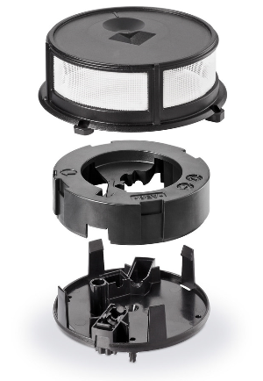

Caption: In the course of improving the production process of fire alarms Celestica recognized Greiner Assistec with a 2016 Total Cost of Ownership Supplier Award.

For inquiries, please contact:
Charlotte Enzelsberger I Communication & PR
Phone: +43 664 88914905
Email: c.enzelsberger@greiner-gpi.com

