PRESS RELEASE

Beatrix Praeceptor designated to become CEO of Greiner Packaging division

- Beatrix Praeceptor to succeed Manfred Stanek as CEO of Greiner Packaging as he moves on to Greiner AG Executive Board from May 1, 2023
- Praeceptor is currently Chief Procurement Officer at the packaging and paper company Mondi and has international experience and management expertise
- The objectives of the designated CEO include continuous global growth with focus on sustainable transformation

Vienna/Kremsmünster, December 1st 2022 – Beatrix Praeceptor is to assume the management of Greiner Packaging International GmbH as of May 1, 2023. She will be succeeding Manfred Stanek, who will be joining Greiner AG’s Executive Board as of January 1, 2023 and will hold a dual role until Praeceptor takes over her position.

Beatrix Praeceptor (55) most recently worked as Chief Procurement Officer for the Mondi Group and has both international industry expertise and management experience with a strong focus on sustainability.

“We are delighted to get Beatrix Praeceptor on board as our division manager. We feel that her personal qualities are an excellent match for our corporate values. Among other things, she convinced us with her cooperative management philosophy, her strong focus on performance and her creative drive,” said Axel Kühner, CEO of Greiner AG.

“I am grateful for the trust placed in me and excited about the new challenge starting next May. The values of Greiner have inspired me from the very beginning as they are very much in line with my understanding of leadership. My goal is to continue the international success story of this family-owned company and to position Greiner Packaging even more strongly as a global player on the world market," said Beatrix Praeceptor.

International experience and commitment to equal opportunities
Beatrix Praeceptor has been Chief Procurement Officer at Mondi Group for eleven years. In this position, she and her international team are responsible not only for cost optimization of the purchasing volume, but also for the sustainable development of more than 18,000 suppliers and the implementation of supplier-specific sustainability targets. Prior to Mondi, she held leading supply chain positions at Lafarge S.A. and Philips Industries. Born in Vienna, she grew up in Canada and Italy and is fluent in German, English, Italian and French. For many years, she has been personally committed to an inclusive work environment and more diversity in companies. Among other things, she was a mentor at Teach For Austria and since 2016 has been engaged with the organizations WoMentoring and TheFemaleFactor, which work to support (young) women. Beatrix Praeceptor is married and the mother of three adult children.

Photo:
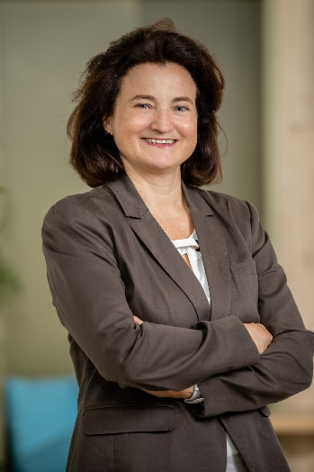
Caption: Beatrix Praeceptor to assume management of Greiner Packaging division from May 1 2023.

Photo credit: Klaus Ranger
The image material is available for free publication in the context of editorial reporting.

About Greiner
Based in Kremsmünster, Austria, Greiner is a world-leading plastics and foam solutions company. With the three operating divisions Greiner Packaging, NEVEON, and Greiner Bio-One, the company is at home in all manner of industrial sectors. Established in 1868, the Group is now one of the leading foam producers and plastics processors for the packaging, furniture, sports, and automotive industries as well as medical technology and the pharmaceutical sector. In fiscal 2021, Greiner generated turnover of EUR 2.27 billion, and had over 11,000 employees at 129 sites in 33 countries. The CEO is Axel Kühner, and the CFO is Hannes Moser.
www.greiner.com

About Greiner Packaging
Greiner Packaging is one of the leading European manufacturers of plastic packaging in the food and non-food sector. For over 60 years, the company has stood for high solution expertise in development, design, production, and decoration. Greiner Packaging meets the challenges of the market with two business units: Packaging and Assistec. While the former stands for innovative packaging solutions, the latter focuses on the production of customized technical parts. Greiner Packaging has over 4,900 employees at more than 30 sites in 19 countries worldwide. In 2021 the company generated annual turnover of EUR 772 million (including joint ventures), representing almost 35% of Greiner’s total turnover.
www.greiner-gpi.com

Media contact
Greiner AG
Gerti Wallner, Media Spokesperson
Mobile: +43 664 88598617
e-mail: presse@greiner.com

