**PET tray-to-tray: Greiner Packaging processes material from yellow bags into beverage trays for Rauch Fruchtsäfte**

**Together with its partners, Greiner Packaging is taking yet another step towards a circular economy: In future, Rauch brand beverages will also be presented in supermarkets in trays made of 70% PCR (post-consumer recycled) r-PET material.**

* In addition to bottles made from 100% r-PET, Rauch now also uses trays made from 70% recycled PET
* Tray-to-tray recycling reduces dependence on the PET bottle flow
* Waste from yellow bags is used as the basis for recycled trays
* The trays are produced by the Greiner Packaging business unit Greiner Assistec, which specializes in the production of customer-specific plastic parts

Supermarket shoppers are all familiar with them: practical trays from which beverage bottles can be removed quickly and easily. They allow for efficient, space-saving, and safe transport of bottles and save supermarket employees the time-consuming task of putting them on the shelves. Taking a further step towards sustainability, Rauch Fruchtsäfte will in future be using beverage trays made of recycled material – the new trays are made of 70% recycled PET.

**Waste acquires new value**

Material taken from yellow bags is used for the beverage trays. In the course of a project, it was proven that r-PET flakes can be produced from post-consumer material by means of thorough pre- and post-sorting followed by shredding and washing. From these flakes, a PET film (70% recycled material) is subsequently extruded, which is then thermoformed into r-PET trays by the Greiner Packaging business unit Greiner Assistec. In terms of quality, the recycled trays are in no way inferior to beverage trays made of new material.

**Promoting independence from the PET bottle flow**

The r-PET flakes are produced from input materials other than PET beverage bottles, such as cups, tubs, and trays. The project thus shows that it is possible to establish alternative PET value flows. After all, to produce packaging from recycled PET, the plastics industry today mainly uses r-PET flakes obtained by recycling PET bottles. This “bottle flow” is already well-established. The potential for recycling other PET packaging from the yellow bag, on the other hand, is not yet being exploited to any great extent. However, the aim is to establish corresponding recycling streams on a large scale in the future.

“For us, creating beverage trays from r-PET material that does not come from the bottle flow is a great opportunity: On the one hand, it means we are focusing on a sustainable product. On the other hand, we are promoting a tray-to-tray cycle. As a beverage manufacturer, we are of course particularly keen to ensure that high-quality r-PET from the bottle flow is also available for the production of new r-PET bottles and that alternative forms of packaging are used for the manufacture of other products,” says Hanno Mandl, purchasing manager at Rauch Fruchtsäfte, about the implementation of the recycling trays.

**Success thanks to expertise**

Greiner Packaging can already look back on many years of experience in processing recycled PET for its packaging. In September 2022, the plastics expert announced the acquisition of a Serbian r-PET flakes recycler, which now operates under the name Greiner Recycling.

“By expanding a year ago, we sent a clear signal and underscored that we believe in the potential of r-PET for a sustainable future of the packaging industry. Even then, it was our clear goal to drive recycling streams away from bottles. The project together with Rauch Fruchtsäfte is just one step on this path, to be followed by many more,” says Peter Fessl, Director Operations Recycling at Greiner Packaging.

**Text & image:**

Text document as well as images in high-resolution quality for download:

<https://greinerpackaging.canto.de/b/REFJ6>

**Credit:** Greiner Packaging; happy day display: Rauch Fruchtsäfte

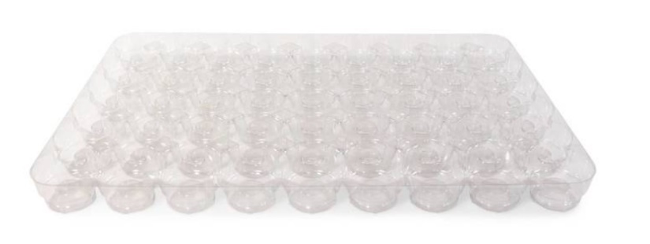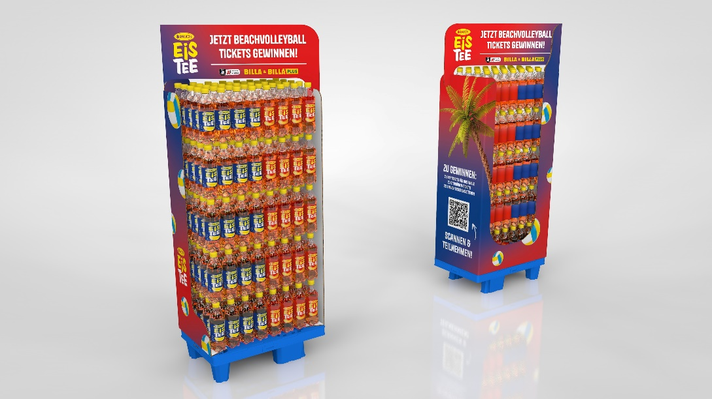

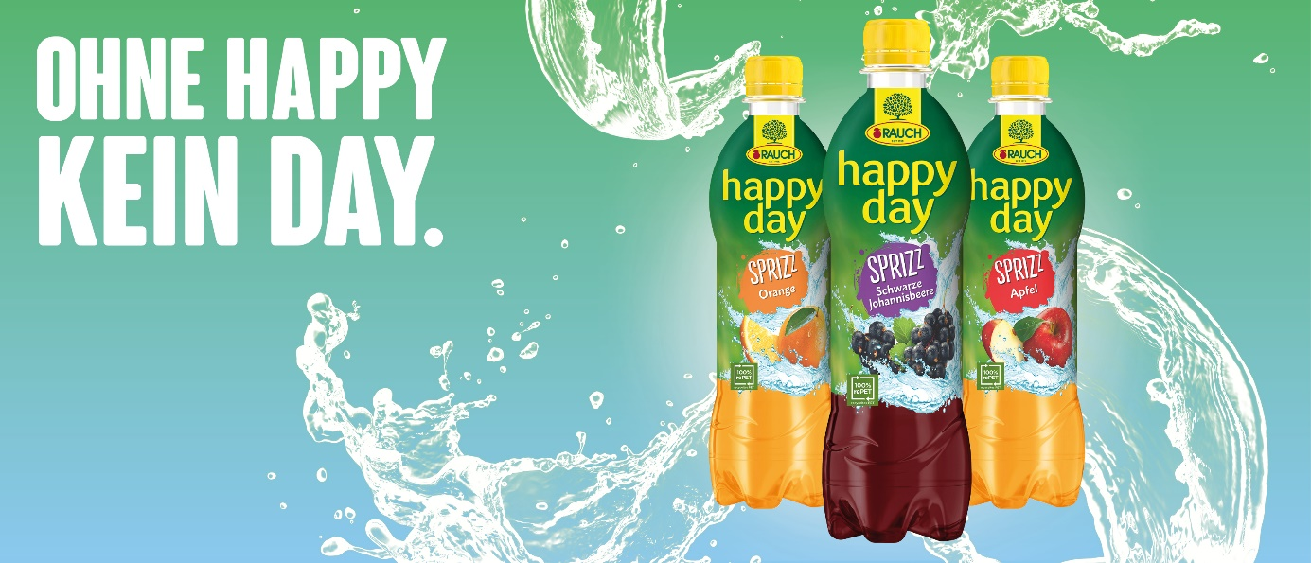

**Caption:** Beverages from Rauch Fruchtsäfte are now offered in trays made of 70% recycled material from yellow bags. The trays are manufactured by Greiner Packaging.

|  |
| --- |
| **About Greiner Packaging**  Greiner Packaging is one of the leading European manufacturers of plastic packaging in the food and non-food sector. For over 60 years, the company has stood for a high level of solution competence in development, design, production, and decoration. Greiner Packaging meets the challenges of the market with two business units: Packaging and Assistec. While the former stands for innovative packaging solutions, the latter focuses on the production of customized technical parts. Greiner Packaging employs over 5,000 people at 30 locations in 19 countries worldwide. In 2022, the company achieved an annual turnover of 909 million euros (incl. joint ventures). This is almost 40% of Greiner’s total turnover.    **Greiner Packaging Media Contact:**  Charlotte Enzelsberger    Greiner Packaging International GmbH    Gewerbestraße 15, 4642 Sattledt, Austria   Mobile: +43 664 88218364    E-mail: [c.enzelsberger@greiner-gpi.com](mailto:c.enzelsberger@greiner-gpi.com) |