Greiner Assistec steps up twin-sheet production for high-quality logistics solutions

Greiner Assistec is a thermoforming specialist. And the plastics experts, whose customers already enjoy a wide range of options, are now offering even more twin-sheet processing solutions. From now on, they will be using a new, state-of-the-art system to thermoform plastic plates up to 2,700 x 1,700 mm in size, allowing them to produce industrial and special-purpose pallets for large load carrier systems.

Kremsmünster, Austria, October 2019. Twin-sheet thermoforming technology is ideal, both for the technically optimal production of trays and boxes for logistics applications and as a method for the cost-effective manufacture of hollow bodies in smaller runs. A key advantage of twin-sheet products is their higher level of rigidity. Fasteners can also be inserted into the space between the plates. Greiner Assistec’s experience and expertise in the thermoforming process were already unique selling points – a position that has now been further enhanced. With state-of-the-art machinery, the plastics experts are able to provide top-class customized packaging solutions as well as hollow bodies and components with the stability appropriate to their applications.

Top-quality custom solutions
“We work closely with our customers to find the ideal production process for each individual project. We can then present the best-fit solution in terms of both quality and efficient cost structure. As well as producing larger format products, we can also use the newly acquired twin-sheet machine to deliver the shortest possible cycle times and, in turn, achieve low production costs,” says Klaus Steineck, sales manager at Greiner Assistec. The equipment can thermoform plastic plates up to 2,700 x 1,700 mm in size, allowing the company to produce industrial and special-purpose pallets for large load carrier systems. As a result, the logistics market in particular stands to benefit, with customers in this sector especially eager to find customized solutions.

Ideal addition to technology lineup
The twin-sheet machine is a perfect complement to Greiner Assistec’s technology portfolio. Product-specific packaging solutions for logistics applications can be created through a combination of thermoforming and injection molding, while hollow bodies can be produced using thermoforming, injection molding (combined with hot plate welding), and technical extrusion blow molding. “Our customers benefit from the best solution to meet their individual needs, regardless of the technology used. Thanks to our many years of design and engineering expertise, along with our strong record of past performance, they can be sure of obtaining the ideal solution for every application,” says Andreas Kaiser, managing director of Greiner Assistec GmbH.

About Greiner Packaging & Greiner Assistec
Greiner Packaging is a leading European manufacturer of plastic packaging in the food and nonfood sectors. The company has enjoyed a reputation for outstanding solutions expertise in the fields of development, design, production, and decoration for nearly 60 years. Greiner Packaging responds to the challenges of the market with two business units: Packaging and Assistec. While the Packaging unit focuses on innovative packaging solutions in the food and nonfood sectors, the Assistec unit is dedicated to producing custom-made technical parts and transit packaging solutions. Greiner Packaging employs a workforce of around 4,800 at more than 30 locations in 19 countries around the world. In 2018, the company generated annual sales revenues of EUR 673 million (including joint ventures), which represents more than one third of Greiner’s total sales.

Text and image:

Text document and high-resolution images for download:
https://mam.greiner.at/pinaccess/showpin.do?pinCode=U9qsVrs5KI3s

Images for royalty-free use (credit: Greiner Packaging)

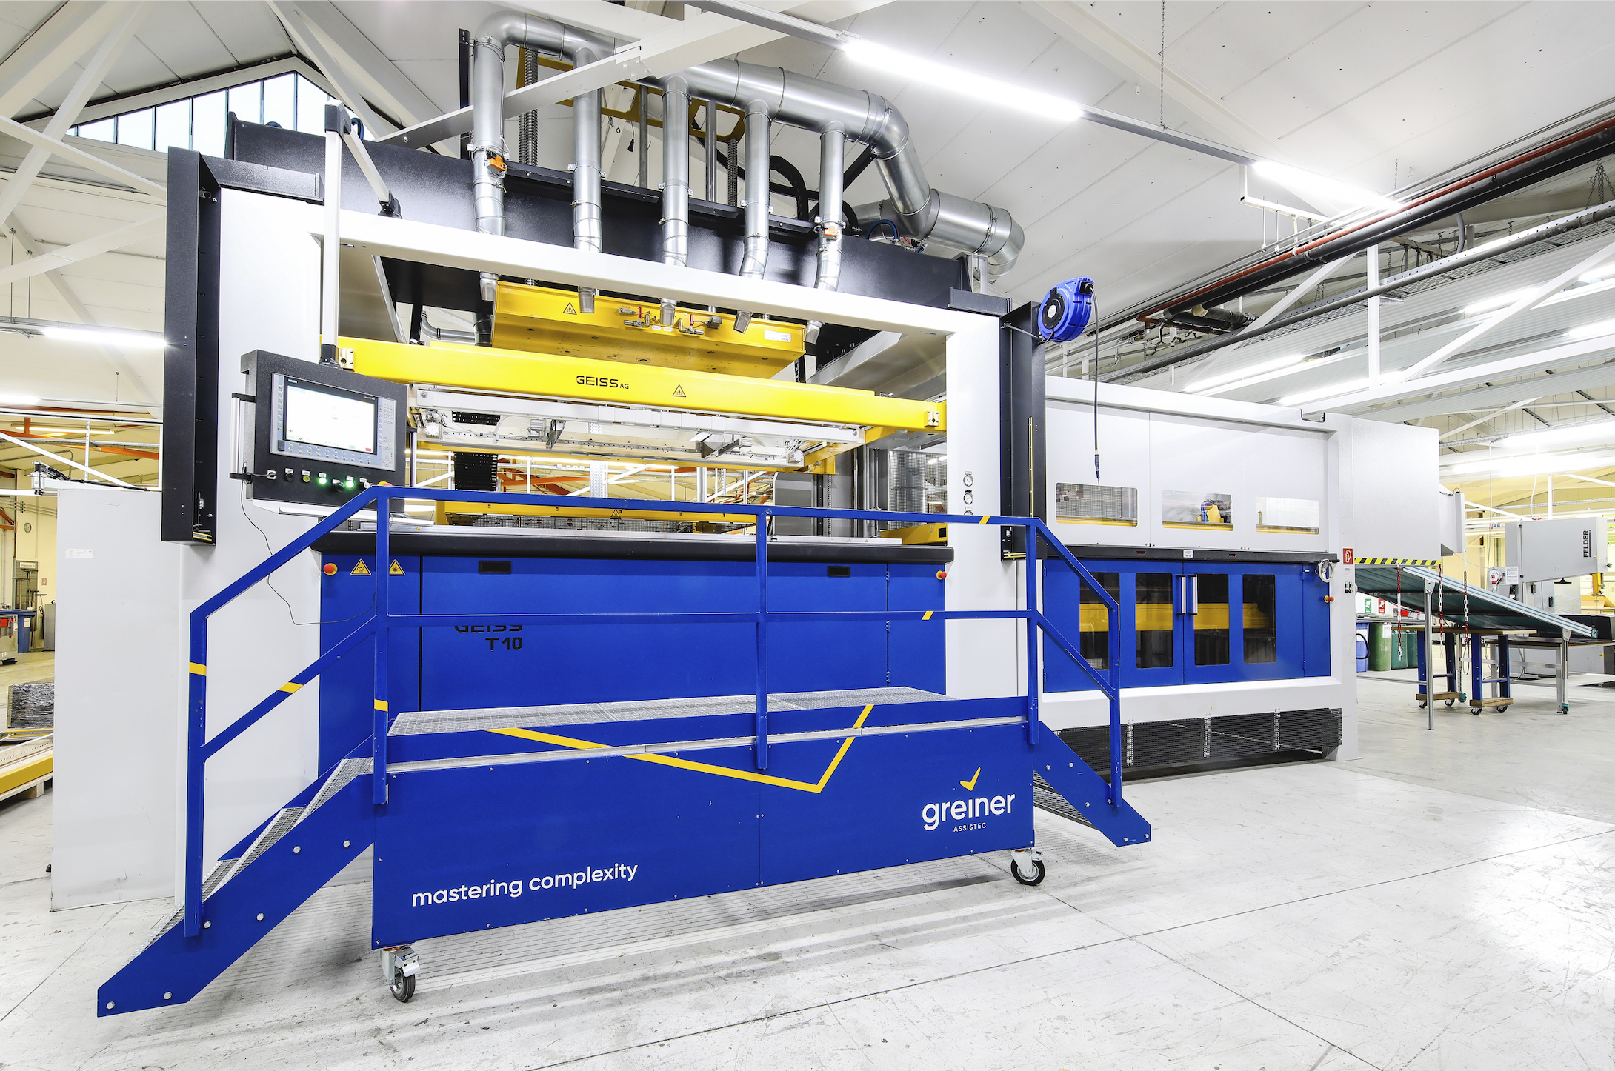

Caption: Greiner Assistec boosts its twin-sheet range with the addition of new machinery.

Please direct any questions to:
Carina Maurer I Text, Design, Concept, and PR
SPS MARKETING GmbH | B 2 Businessclass | Linz, Stuttgart
Jaxstrasse 2–4, 4020 Linz, Austria
Tel.: +43 (0) 732 60 50 38-29
E-mail: c.maurer@sps-marketing.com
www.sps-marketing.com

